Evolving Control Systems

**Abstract**

If you were to consider the human brain as the control system of the body. The neurons and synapses would be the network that connects the brain to the other mechanical components of the body.

<https://droso4schools.files.wordpress.com/2015/10/fundamentalwiring.gif?w=600&h=614>

There are two types of neurons; motor neurons and sensor neurons.

<https://opentextbc.ca/anatomyandphysiology/wp-content/uploads/sites/142/2016/03/1212_Sensory_Neuron_Test_Water.jpg>

**Introduction**

**[Present Robot without any Neurons and Synapses]**

**[Present Robot with random Neurons and Synapses]**

**\*\***Goal is to move the robot to the light source*

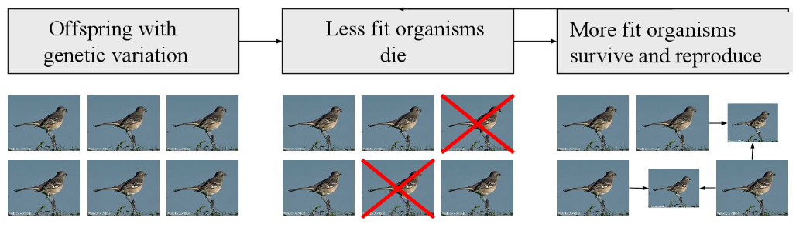

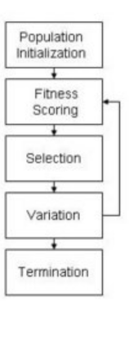

Creating a controller for a complicated body is non-intuitive and requires automation.

Learning algorithms can only optimize single controllers; but by evolving a control system can optimize the entire system.

Biological evolution can produce adaptive agents of unparalleled complexity with no supervision.

Population Initialization

**What does a Neural Network Look life?**

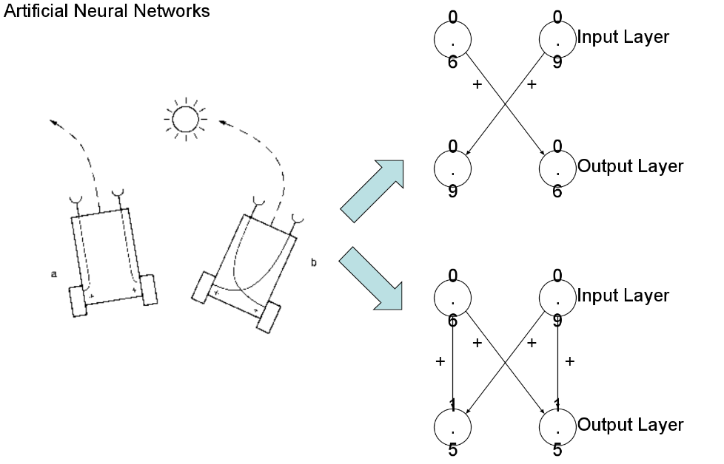

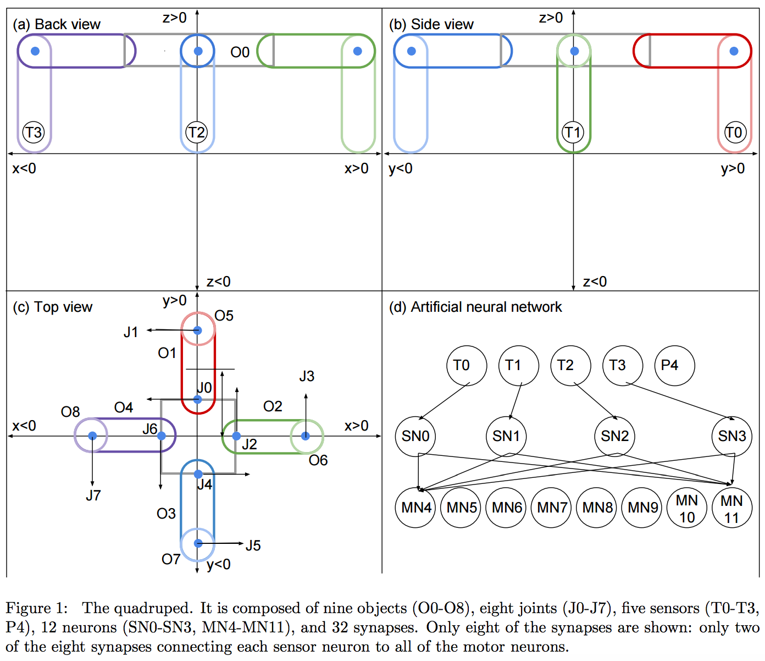

Show a 4 x 8 Matrix where ‘I’ corresponds to the sensor and ‘j’ corresponds to the motor….

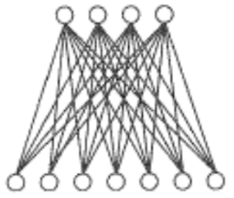

Fitness Scoring

Test in a variety of Environments – We have the light source in 4 particular spots. We don’t set the light source in random spots, because this will not allow the robot to simply ‘get lucky’.

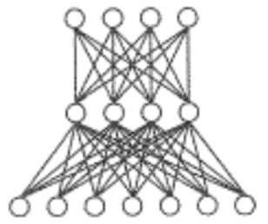

Selection

1. Maintain Elitism
2. Maintain Diversity (Uniqueness)
   1. Occasional Rapture

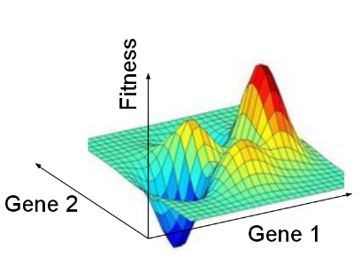

Variation

1. Randomly change a synapse value
2. Primitive Breed method; this includes masking off certain synapses and replace with synapose values of another individual.
3. Slight Bias in the system
4. NEAT/HyperNEAT

Hidden/Recurrent Neurons

